**控制器基类 ControllerBase 和Controller的区别：**

他们都来自于同一个命名空间：using Microsoft.AspNetCore.Mvc;

**Controller**

首先，可以看到Controller这个类继承了ControllerBase基类，并提供了对View的支持

包含有：ViewData, JsonResule, Action Event, View, ViewComponentResult

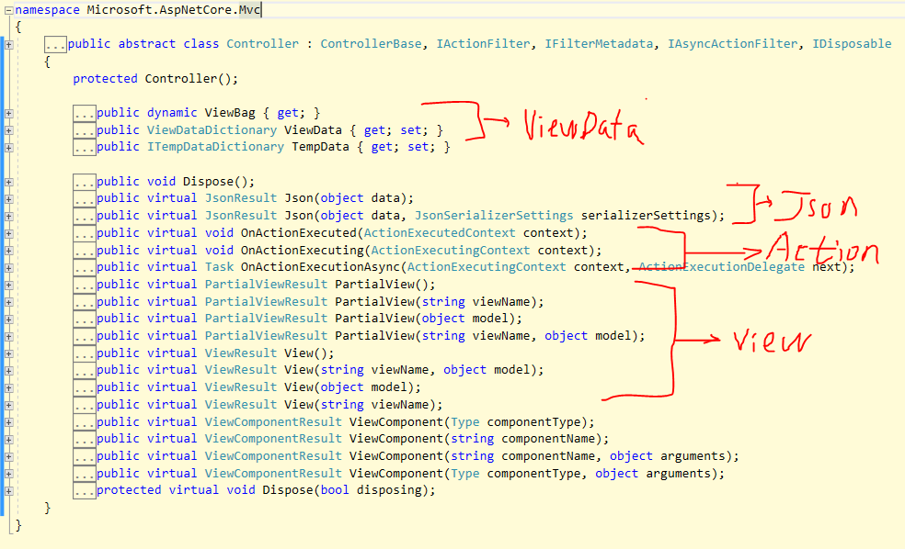

**ControllerBase :** 并不提供对 View 的支持， 只包含请求信息头信息等， 和返回的数据格式与结果

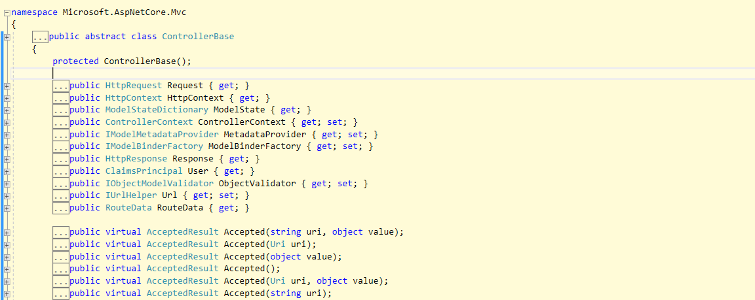

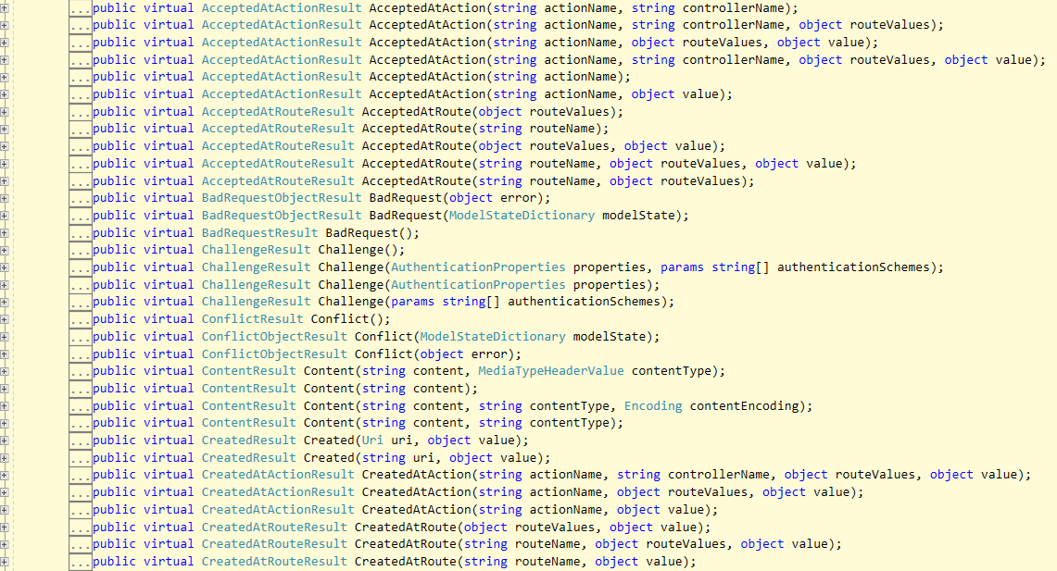

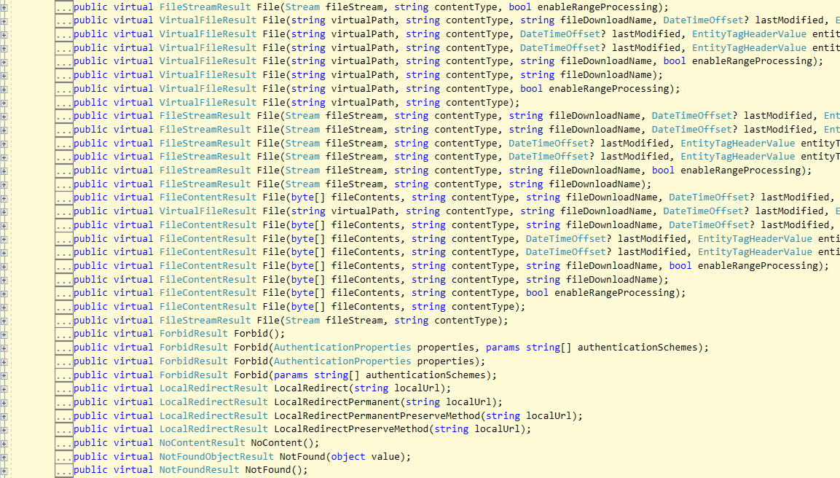

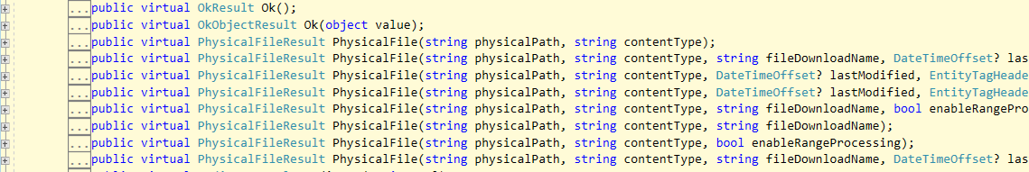

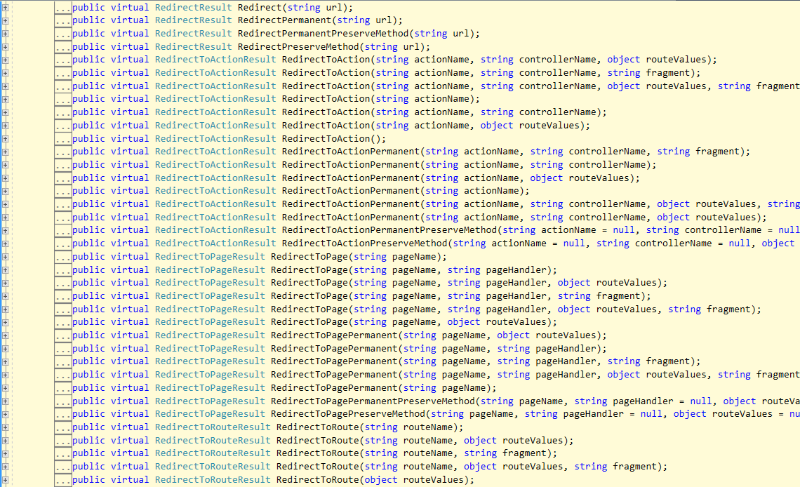

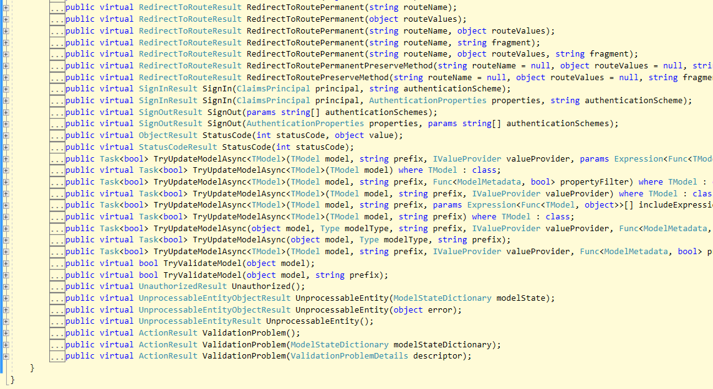

总结： 如果是 MVC 框架则使用 Controller, 如果是WebApi 用于数据提供则使用 ControllerBase

Controller继承自ControllerBase , 凡是ControllerBase有的特性, Controller 都有

**ControllerBase:**

ActionResult - 是其他返回类型的基础

public abstract class ActionResult : IActionResult

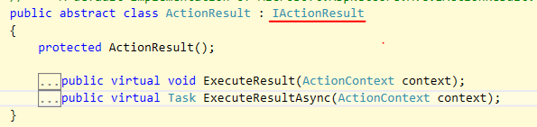

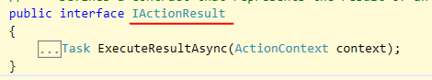

ActionResult 作为 WebApi 返回类型：

1. 通常习惯使用 IActionResult 来替代 ActionResult 作为返回类型
2. ActionResult 不能直接返回类型, 需要调用其他的辅助方法来返回数据。

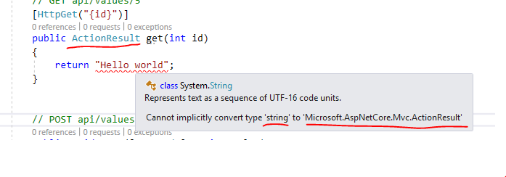

1. ActionResult 是其他返回类型的基础类型：并其它是抽象类。把它作为WebApi的返回类型，只能通过调用其他的辅助方法来返回不同类型 (这些类型都是直接或多层继承自ActionResult）

ObjectResult - StatusCode()

AcceptedResult - Accepted()

StatusCodeResult – StatusCode()

ContentResult – Content()

OkResult – Ok()

OkObjectResult – Ok()

BadRequestResult – BadRequest()

BadRequestObjectResult - BadRequest()

ForbidResult – Forbid()

SignInResult - SignIn()

1. 如果我们使用辅助方法来返回数据不方便，可以使用ActionResult<TValue> 这样可以直接返回所需要的类型。

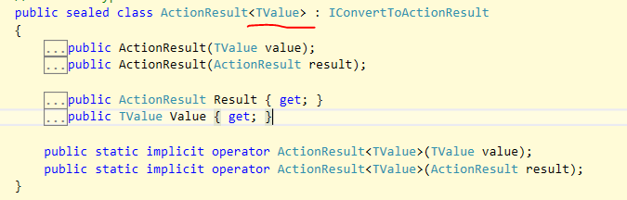

注意： 泛类型没有 IActionResult<TValue>, 只有ActionResult<TValue>

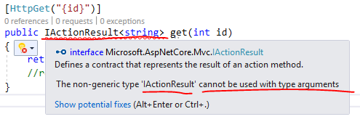

使用泛类型的缺点， 不能很好的处理错误：

[HttpGet("{id}")]

public ActionResult<int> get(int id)

{

try

{

int a = 100;

int b = 0;

int c = a / b;

return c;

}

catch(Exception err)

{

throw err;

}

}

StatusCode: 500 Internal Server Error

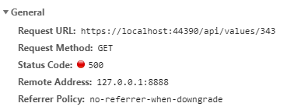

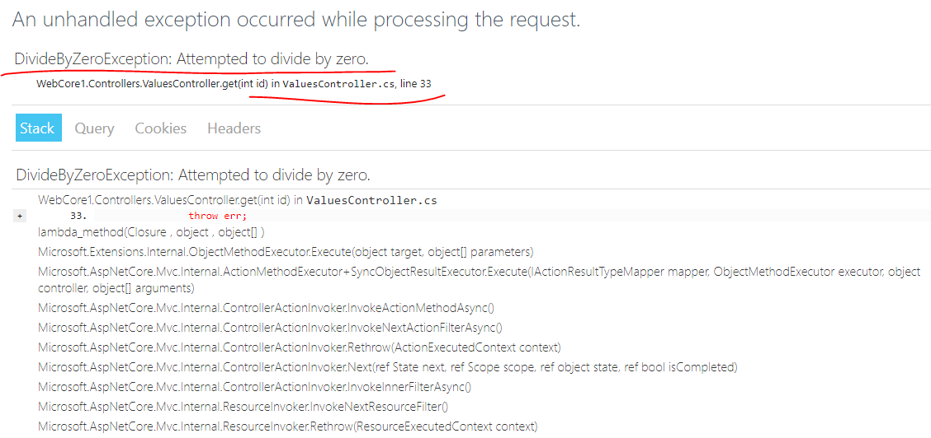

关于WebApi 的环境依赖注入问题：

WebApi Controller 的构造函数本身可以自动绑定

[Route("api/[controller]")]

[ApiController]

public class CoursesController : ControllerBase

{

public CourseDB DB { get; set; }

public CoursesController(

IHostingEnvironment env,

IOptions<**SQLConfig**> sqlConfig,

IConfiguration conf

)

{

this.Env = env;

this.DB = new CourseDB(sqlConfig.Value);

}

[HttpGet]

public IActionResult Get()

{

}

}

StartUp.cs

public class Startup

{

public Startup(IConfiguration configuration)

{

Configuration = configuration;

}

public IConfiguration Configuration { get; }

// This method gets called by the runtime. Use this method to add services to the container.

public void ConfigureServices(IServiceCollection services)

{

services.AddMvc().SetCompatibilityVersion(CompatibilityVersion.Version_2_1);

services.Configure<**SQLConfig**>(Configuration.GetSection("SQLServer"));

services.AddSpaStaticFiles(configuration =>

{

configuration.RootPath = "ClientApp/dist";

});

services.AddDistributedMemoryCache();

services.AddSession(options =>

{

// Set a short timeout for easy testing.

options.IdleTimeout = TimeSpan.FromSeconds(3600 * 24);

options.Cookie.HttpOnly = true;

});

}

public void Configure(IApplicationBuilder app, IHostingEnvironment env)

{

if (env.IsDevelopment())

{

app.UseDeveloperExceptionPage();

}

else

{

app.UseExceptionHandler("/Error");

app.UseHsts();

}

app.UseHttpsRedirection();

app.UseStaticFiles();

app.UseSpaStaticFiles();

app.UseSession();

app.UseMvc(routes =>

{

routes.MapRoute(

name: "default",

template: "{controller=Home}/{action=Index}/{id?}");

});

app.UseSpa(spa =>

{

// To learn more about options for serving an Angular SPA from ASP.NET Core,

// see https://go.microsoft.com/fwlink/?linkid=864501

spa.Options.SourcePath = "ClientApp";

if (env.IsDevelopment())

{

spa.UseAngularCliServer(npmScript: "start");

}

});

}

}

# Use the Angular project template with ASP.NET Core

<https://docs.microsoft.com/en-us/aspnet/core/client-side/spa/angular?view=aspnetcore-2.1&tabs=visual-studio>

* 传统的ASP.NET MVC 的路由

protected void Application_Start()

{

AreaRegistration.RegisterAllAreas();

FilterConfig.RegisterGlobalFilters(GlobalFilters.Filters);

RouteConfig.RegisterRoutes(RouteTable.Routes);

BundleConfig.RegisterBundles(BundleTable.Bundles);

}

public static void RegisterRoutes(RouteCollection routes)

{

routes.IgnoreRoute("{resource}.axd/{*pathInfo}");

routes.MapRoute(

name: "Default",

url: "{controller}/{action}/{id}",

defaults: new { controller = "Home", action = "Index", id = UrlParameter.Optional }

);

}

传统的MVC + WEBAPI路由机制：

激活 [RoutePrefix()] 和 [Route()] 必须添加MapHttpAttributeRoutes()

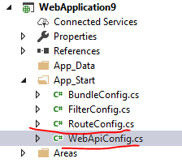

MVC 的路由配置

public class RouteConfig

{

public static void RegisterRoutes(RouteCollection routes)

{

routes.**MapMvcAttributeRoutes**(); - 这是激活 MVC 的[RoutePrefix()] 和 [Route()]

routes.IgnoreRoute("{resource}.axd/{*pathInfo}");

routes.MapRoute(

name: "Default",

url: "{controller}/{action}/{id}",

defaults: new { controller = "Home", action = "Index", id = UrlParameter.Optional }

);

}

}

有了上面的正确配置：

[RoutePrefix("sales/home")]

public class HomeController : Controller

{

[Route("haha")]

public ActionResult Index()

{

ViewBag.Title = "Home Page";

return View();

}

}

WebApi 的路由配置

public static class WebApiConfig

{

public static void Register(HttpConfiguration config)

{

config.MapHttpAttributeRoutes(); - 激活WebApi的 [RoutePrefix()] 和 [Route()]

config.Routes.MapHttpRoute(

name: "DefaultApi",

routeTemplate: "api/{controller}/{id}",

defaults: new { id = RouteParameter.Optional }

);

}

}

有了上面的正确配置：

[RoutePrefix("sales/order")]

public class ValuesController : ApiController

{

[Route("detail")]

// GET api/values

public IEnumerable<string> Get()

{

return new string[] { "value1", "value2" };

}

}

* ASP.Net Core 的路由机制:

默认的设置：

public void ConfigureServices(IServiceCollection services)

{

services.AddMvc().SetCompatibilityVersion(CompatibilityVersion.Version_2_1);

}

如果选择的是 ASP.Net Core Web Application:

public void Configure(IApplicationBuilder app, IHostingEnvironment env)

{

if (env.IsDevelopment())

{

app.UseDeveloperExceptionPage();

}

else

{

app.UseExceptionHandler("/Error");

app.UseHsts();

}

app.UseHttpsRedirection();

app.UseStaticFiles();

app.UseCookiePolicy();

app.**UseMvc**();

}

1. app.**UseMvc**() 并没有指定路由规则，为什么可以自动路由WebApi 的请求

app.UseMvc() – 并没有设置路由规则，只是启用路由功能，WebApi 之所以能被路由

是因为: 有指定[Route]

[**Route**("api/[controller]")]

[ApiController]

public class ValuesController : ControllerBase

{

public IHostingEnvironment Env;

public IConfiguration Config;

public ValuesController(IHostingEnvironment env, IConfiguration config)

{

this.Env = env;

this.Config = config;

}

// GET api/values

[HttpGet]

public ActionResult<IEnumerable<string>> Get()

{

int a = 100;

int b = 15;

int c = a / b;

return new string[] { $"a={a}", $"b={b}", $"a/b={c}" };

}

}

那么对于Asp.Net Core 里有 MVC 应用：

<https://localhost:44364/home/index>

public class HomeController : Controller

{

public IActionResult Index()

{

return View();

}

public IActionResult Error ()

{

return View();

}

public IActionResult Contact([FromRoute] string myurl)

{

var con = RouteData.Values["CONTROLLER"];

var act = RouteData.Values["ACTion"];

var myu = RouteData.Values["MYURL"];

ViewBag.myu = myurl;

return View();

}

}

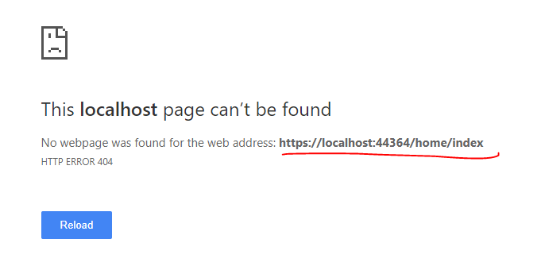

[Route("HOME")]

public class HomeController : Controller

{

[Route("Haha")] - 这里有定义路由

public IActionResult Index()

{

return View();

}

public IActionResult Error ()

{

return View();

}

public IActionResult Contact([FromRoute] string myurl) - 这里没有定义路由

{

var con = RouteData.Values["CONTROLLER"];

var act = RouteData.Values["ACTion"];

var myu = RouteData.Values["MYURL"];

ViewBag.myu = myurl;

return View();

}

}

注意只有定义路由的Action 才能被执行

<https://localhost:44364/home/haha> - 这个可以路由到此页面

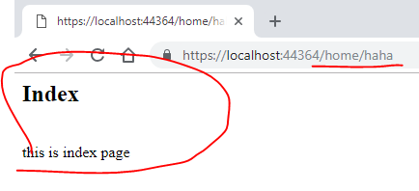

<https://localhost:44364/home/contact> - 由于Action 上没有定义路由，所以找不到

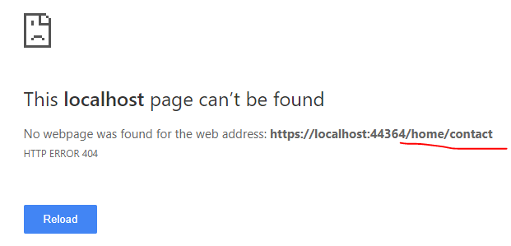

1. 如果在 Configure 里不指定： app.UseMvc() 则无法路由所有的请求

<https://localhost:44364/api/values>

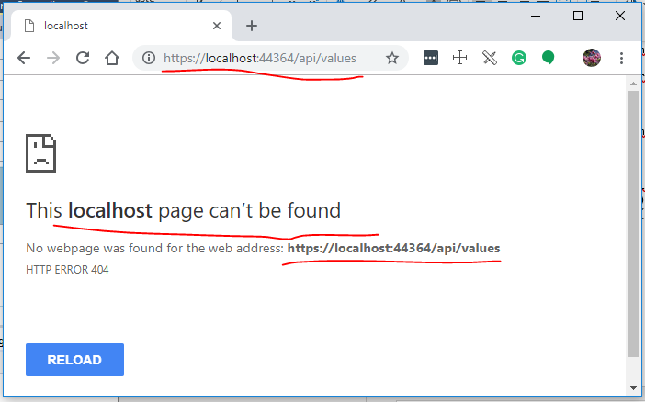

1. 在 Configure 里指定： MVC 的路由

如果选择的是 ASP.Net Core Web Application (MVC)

public void Configure(IApplicationBuilder app, IHostingEnvironment env)

{

if (env.IsDevelopment())

{

app.UseDeveloperExceptionPage();

}

else

{

app.UseExceptionHandler("/Home/Error");

app.UseHsts();

}

app.UseHttpsRedirection();

app.UseStaticFiles();

app.UseCookiePolicy();

app.UseMvc(routes =>

{

routes.MapRoute(

name: "default",

template: "{controller=Home}/{action=Index}/{id?}");

});

}

也可以使用默认 defaults: new { controller= “”, action=”” },

app.UseMvc(routes =>

{

routes.MapRoute(

name: "default",

template: "{controller}/{action}/{id?}",

defaults: new { controller = "home", action = "index" }

);

});

Controller, Action 大小写无所谓

app.UseMvc(routes =>

{

routes.MapRoute(

name: "default",

template: "{controller}/{action}/{id?}",

defaults: new { Controller="Home", Action="contact" }

);

});

也可以往路由里添加其他默认 key => value

app.UseMvc(routes =>

{

routes.MapRoute(

name: "default",

template: "{controller}/{action}/{myurl}",

defaults: new { Controller="Home", Action="contact", myurl="lwh.cshtml" }

);

});

我们可以从WebApi 的具体 Action 里取回路由值：RouteData.Values[ keyName ] keyName 大小写无所谓

public class HomeController : Controller

{

public IActionResult Index()

{

return View();

}

public IActionResult Error ()

{

return View();

}

public IActionResult Contact([FromRoute] string myurl)

{

var con = RouteData.Values["CONTROLLER"];

var act = RouteData.Values["ACTion"];

var myu = RouteData.Values["MYURL"];

ViewBag.myu = myurl;

return View();

}

}

因为全局已经指定了路由， 所以 MVC 里的 controller 和 action 可以不需要指定路由。

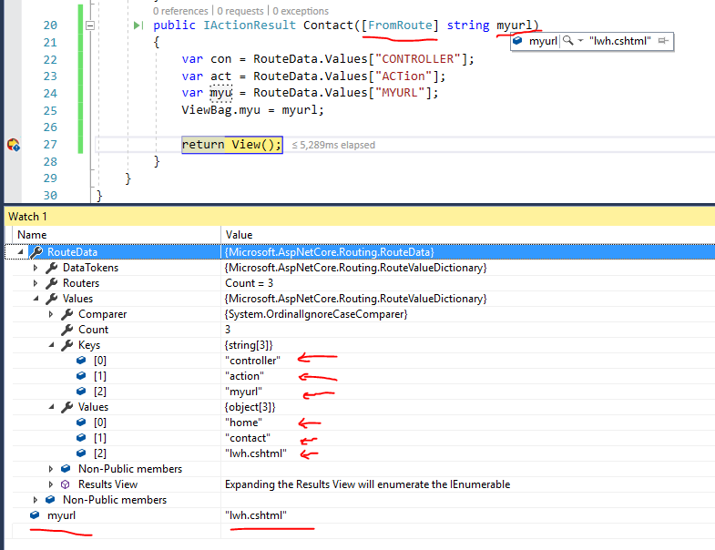

1. 在 Configure 里指定： WebApi 的路由

[Route("api/[controller]")]

[ApiController]

public class ValuesController : ControllerBase

{

public IHostingEnvironment Env;

public IConfiguration Config;

public ValuesController(IHostingEnvironment env, IConfiguration config)

{

this.Env = env;

this.Config = config;

}

// GET api/values

[HttpGet("take")]

public ActionResult<IEnumerable<string>> Get()

{

int a = 100;

int b = 15;

int c = a / b;

return new string[] { $"a={a}", $"b={b}", $"a/b={c}" };

}

// GET api/values/5

[HttpGet("{id}")]

public ActionResult<string> get(int id)

{

return $"Get id = {id}";

}

// POST api/values

[HttpPost]

public IActionResult Post([FromBody] StuModel stu)

{

return Ok(stu);

}

// PUT api/values/5

[HttpPut("{id}")]

public string Put(int id)

{

int a = 100;

int b = 20;

int c = a / b;

return $"Result: {a / b} id={id}";

}

// DELETE api/values/5

[Route("delete/{id}")]

public async Task<string> Delete(int id)

{

return await Task.FromResult<string>($"Delete id={id}");

}

}

注意事项：

1. WebApi 只涉及数据的返回，不需要考虑 View, 所以使用 ControllerBase 即可
2. 必须要使用 [ApiController], 以更自动映射Method => Action (Get, Post, Put, Delete), 否则不会映射

[Route("api/[controller]")] - 必须指定以区分其他的路由

[ApiController] – 必须指定否则不会映射到对应的Action

1. 关于 [HttpPost], [HttpGet], [HttpPut], [HttpDelete], [Route] 都可以重定义路由的 URL

[HttpPost], [HttpGet], [HttpPut], [HttpDelete], [Route] 都继承自 IRouteTemplateProvider

所以都可以改写路由URL

1. 在 .Net Core WebApi 没有 [RoutePrefix()], 只能在全局里定义

public static class MvcOptionsExtensions

{

public static void UseCentralRoutePrefix(this MvcOptions opts, IRouteTemplateProvider routeAttribute)

{

// 添加我们自定义 实现IApplicationModelConvention的RouteConvention

opts.Conventions.Insert(0, new RouteConvention(routeAttribute));

}

}

public class RouteConvention : IApplicationModelConvention

{

private readonly AttributeRouteModel _centralPrefix;

public RouteConvention(IRouteTemplateProvider routeTemplateProvider)

{

_centralPrefix = new AttributeRouteModel(routeTemplateProvider);

}

//接口的Apply方法

public void Apply(ApplicationModel application)

{

//遍历所有的 Controller

foreach (var controller in application.Controllers)

{

// 已经标记了 RouteAttribute 的 Controller

var matchedSelectors = controller.Selectors.Where(x => x.AttributeRouteModel != null).ToList();

if (matchedSelectors.Any())

{

foreach (var selectorModel in matchedSelectors)

{

// 在 当前路由上 再 添加一个 路由前缀

selectorModel.AttributeRouteModel = AttributeRouteModel.CombineAttributeRouteModel(_centralPrefix,

selectorModel.AttributeRouteModel);

}

}

// 没有标记 RouteAttribute 的 Controller

var unmatchedSelectors = controller.Selectors.Where(x => x.AttributeRouteModel == null).ToList();

if (unmatchedSelectors.Any())

{

foreach (var selectorModel in unmatchedSelectors)

{

// 添加一个 路由前缀

selectorModel.AttributeRouteModel = _centralPrefix;

}

}

}

}

}

public void ConfigureServices(IServiceCollection services)

{

//services.AddMvc().SetCompatibilityVersion(CompatibilityVersion.Version_2_1);

services.AddMvc(opt=> {

opt.UseCentralRoutePrefix(new RouteAttribute("myapp/v2"));

}).SetCompatibilityVersion(CompatibilityVersion.Version_2_1);

}

<https://www.cnblogs.com/savorboard/p/dontnet-IApplicationModelConvention.html>

注意： 只对 MVC 起作用， WebApi 则工作不正常， 不是很好的解决方案，用处不大

1. 扩展默认路由

app.UseMvc(routes =>

{

routes.MapRoute(

name: "Contact",

template: "about",

defaults: new { Controller="home", Action="about", yeep="Sohu"}

);

routes.MapRoute(

name: "default",

template: "{controller}/{action}/{myurl}",

defaults: new { Controller="Home", Action="contact", myurl="lwh.cshtml" }

);

});

https://localhost:44364/about

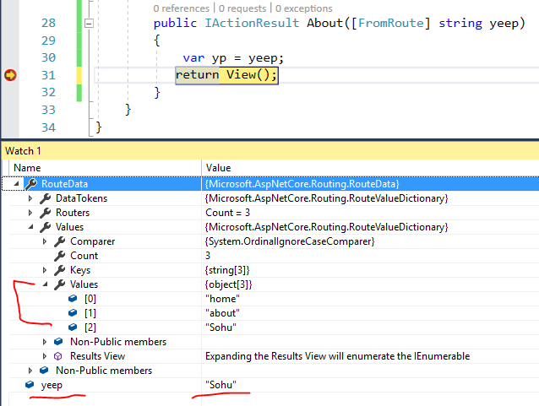

如果在Controller 里有定义路由，则覆盖全局的路由定义

[Route("[controller]/[action]/{myurl}")]

public class HomeController : Controller

{

public IActionResult Index()

{

return View();

}

public IActionResult Error ()

{

return View();

}

public IActionResult Contact([FromRoute] string myurl)

{

var con = RouteData.Values["CONTROLLER"];

var act = RouteData.Values["ACTion"];

var myu = RouteData.Values["MYURL"];

ViewBag.myu = myurl;

return View();

}

public IActionResult About([FromRoute] string yeep)

{

var yp = yeep;

return View();

}

}

<https://localhost:44364/about> - 找不到

<https://localhost:44364/home/index> - 找不到

<https://localhost:44364/home/index/dkdkf> - 找到匹配，多出一个路由值 myurl

<https://localhost:44364/home/contact/dkdkf> - 找到匹配

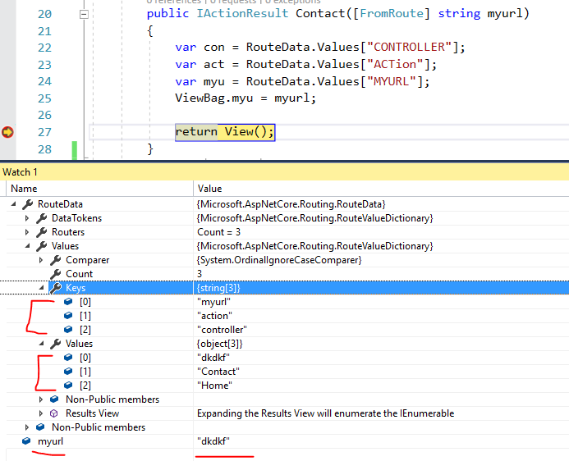

1. [Route("[controller]")] 和 [Route("[action]")] 都是引用的声明的控制器名称和方法名称，即Home控制器和Index方法.可选参数 {xxx?} 加问号

[Route("[action]/{yeep=Good}")] 也可以带默认值，如果有默认值，不带参数也可以被匹配到，参数使用默认值。

其他可选路由参数：

[Route("[action]/{myu**?**}")]

public IActionResult Index([FromRoute] string myu)

{

var url = myu;

return View();

}

<https://localhost:44364/home/index> - 路由匹配， myu = null

<https://localhost:44364/home/index/jackwu> - 路由匹配， myu = jackwu

[Route("[action]/{myu?}")]

public IActionResult Index([FromRoute] int myu)

{

var url = myu;

return View();

}

<https://localhost:44364/home/index> - 路由匹配， myu = 0

<https://localhost:44364/home/index/jackwu> - 路由匹配， myu = 0

<https://localhost:44364/home/index/16.89883> - 路由匹配， myu = 0

<https://localhost:44364/home/index/899> - 路由匹配， myu = 899

[Route("[action]/{myu}")]

public IActionResult Index([FromRoute] DateTime myu)

{

var url = myu;

return View();

}

<https://localhost:44364/home/index> - 路由不匹配，路由参数必须

<https://localhost:44364/home/index/993> - 路由匹配，myu=日期最小值

1. dfasdfds

* ASP.Net Core: json 配置文件的注入问题：

1. 注入整个IConfiguration

public Startup(IConfiguration configuration)

{

Configuration = configuration;

}

默认的IConfiguration 注入了5 个 项目

其中两个 JSON 文件： appsettings.json 和 appsettings.Development.json

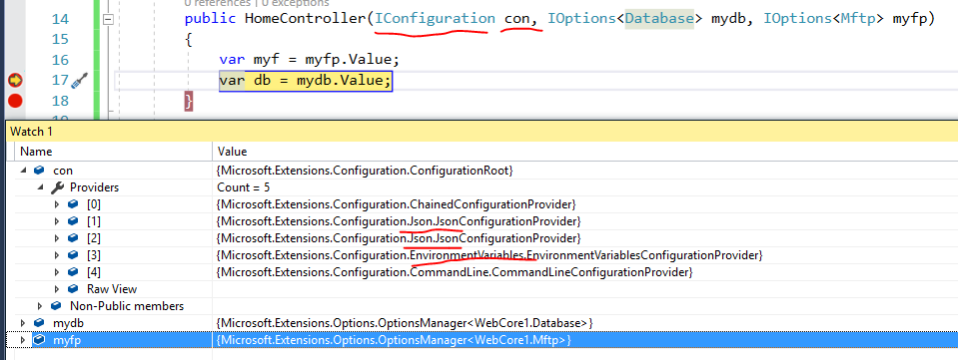

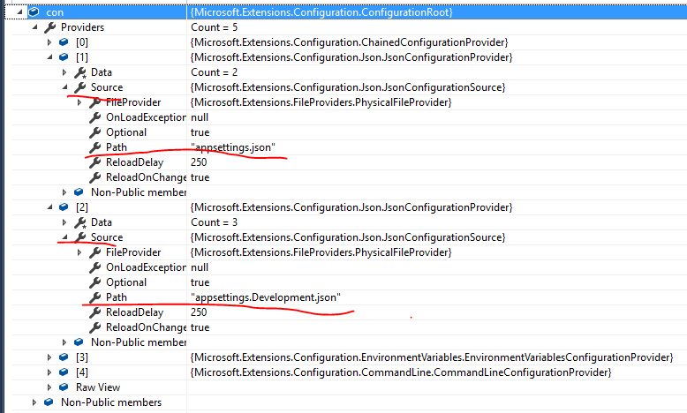

我们可以自定义IConfiguration 并注入到所有Controller

IConfigurationBuilder builder = new ConfigurationBuilder();

builder.SetBasePath(AppDomain.CurrentDomain.BaseDirectory)

.AddXmlFile(path: "lwh.xml", optional: false, reloadOnChange: true)

.AddJsonFile(path: "lwh.json", optional: false, reloadOnChange: true)

.AddJsonFile(path: "lwh1.json", optional: false, reloadOnChange: true)

.AddEnvironmentVariables();

IConfigurationRoot mycon = builder.Build();

services.AddSingleton<IConfiguration>(mycon);

lwh.xml

<?xml version="1.0" encoding="utf-8" ?>

<servers>

<database>

<host>Localhost:333</host>

<user>SA</user>

<trust>true</trust>

<yeep>XML Yeep</yeep>

</database>

</servers>

Lwh.json

{

"database": {

"host": "localhost",

"user": "dba",

"pwd": "889"

},

"website": "www.d3security.com",

"ftp": {

"server": "ftp://qa.d3security.com",

"uid": "567",

"password": "d3456"

}

}

Lwh1.json

{

"database": {

"user": "superman",

"flag": "good"

},

"website": "www.d3security.com",

"ftp": {

"uid": "998",

"trans": "Vancouver"

}

}

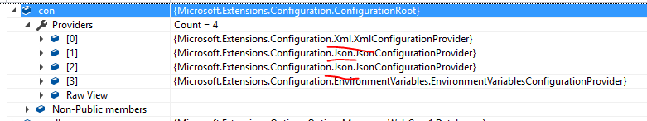

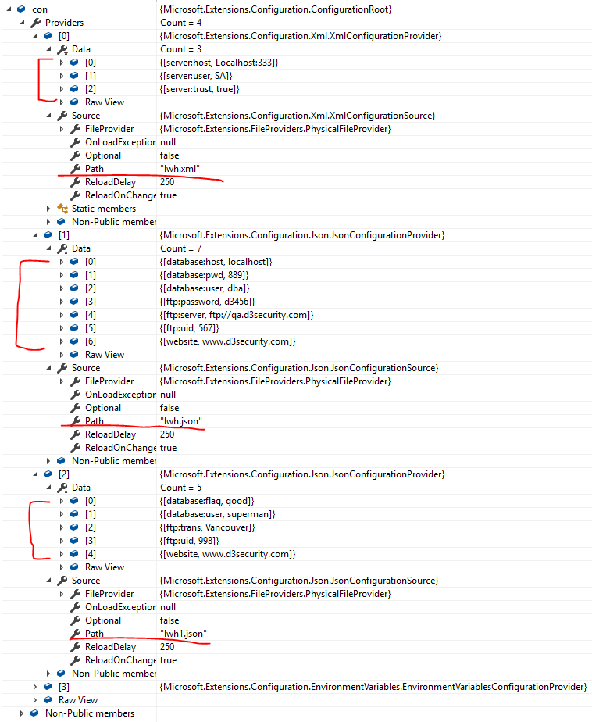

如何读取IConfiguration的值呢：

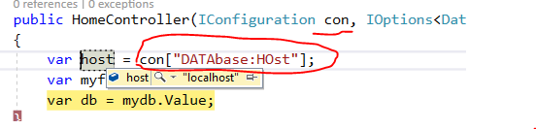

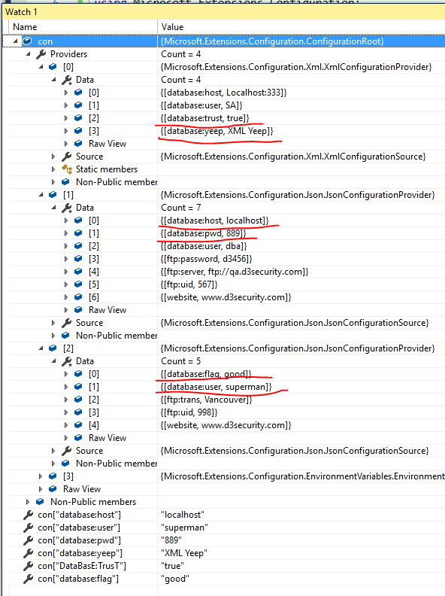

总结：

1. 我们可以看到所有的Config的键值都放在一个字典里，关键字大小写无所谓： host, Host, HOst
2. 无论我们添加多少个文件，最终都会自动合并，相同的键值后面的覆盖前面的。
3. 所有值都是字符串，需要自行转化成自己想要的值。
4. GetSession 方法是返回一个字典项目，和获取字典方法是一样 con[“key”]

con.GetSection("database:host")

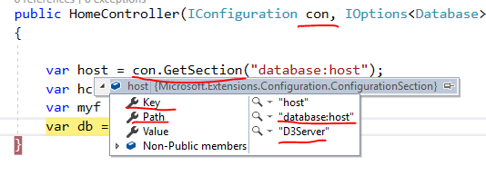

我们把加载自定义文件的顺序改变一下：

IConfigurationBuilder builder = new ConfigurationBuilder();

builder.SetBasePath(AppDomain.CurrentDomain.BaseDirectory)

.AddJsonFile(path: "lwh.json", optional: false, reloadOnChange: true)

.AddJsonFile(path: "lwh1.json", optional: false, reloadOnChange: true)

//这次把 XML 内容放到最后

.AddXmlFile(path: "lwh.xml", optional: false, reloadOnChange: true)

.AddEnvironmentVariables();

IConfigurationRoot mycon = builder.Build();

services.AddSingleton<IConfiguration>(mycon);

lwh.xml内容：

<?xml version="1.0" encoding="utf-8" ?>

<servers>

<database>

<host>D3Server</host>

<user>SA</user>

<trust>true</trust>

<yeep>XML Yeep</yeep>

</database>

</servers>

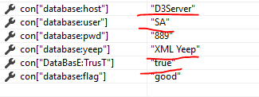

我们看到， 合并：相同的键值后面的覆盖前面的

1. 在程序启动阶段，添加自定义配置文件：

public static void Main(string[] args)

{

CreateWebHostBuilder(args).Build().Run();

}

public static IWebHostBuilder CreateWebHostBuilder(string[] args) =>

WebHost.CreateDefaultBuilder(args)

.ConfigureAppConfiguration((hostingContext, config) =>

{

config.SetBasePath(Directory.GetCurrentDirectory())

.AddJsonFile(path: "lwh.json", optional: false, reloadOnChange: true)

.AddJsonFile(path: "lwh1.json", optional: false, reloadOnChange: true)

.AddXmlFile(path: "lwh.xml", optional: false, reloadOnChange: true);

})

.UseStartup<Startup>();

并不会覆盖默认的，而是添加到默认IConfiguration后面, 如下图：

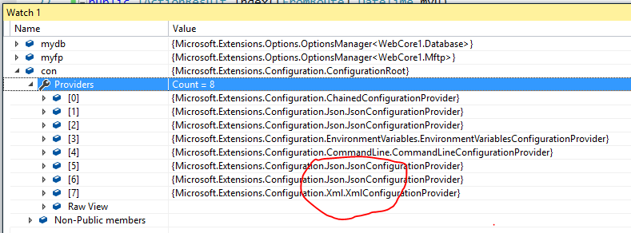

1. 注入IOptions<OptionSample类>

先定义一个OptionSample类需要实现IOptions接口

public class Database

{

public string host { get; set; }

public string user { get; set; }

public int pwd { get; set; }

public string flag { get; set; }

public string yeep { get; set; }

}

public class Mftp

{

public string server { get; set; }

public int uid { get; set; }

public string password { get; set; }

public string trans { get; set; }

}

public void ConfigureServices(IServiceCollection services)

{

services.AddMvc().SetCompatibilityVersion(CompatibilityVersion.Version_2_1);

IConfigurationBuilder builder = new ConfigurationBuilder();

builder.SetBasePath(AppDomain.CurrentDomain.BaseDirectory)

.AddJsonFile(path: "lwh.json", optional: false, reloadOnChange: true)

.AddJsonFile(path: "lwh1.json", optional: false, reloadOnChange: true)

.AddXmlFile(path: "lwh.xml", optional: false, reloadOnChange: true)

.AddEnvironmentVariables();

IConfigurationRoot mycon = builder.Build();

services.Configure<Database>(mycon.GetSection("database"));

services.Configure<Mftp>(mycon.GetSection("ftp"));

}

# 这样做的好处，不会把默认的 IConfiguration 覆盖掉，而且是以强命名的对象读取数据

# 

public static IWebHost BuildWebHost(string[] args) =>

WebHost.CreateDefaultBuilder(args)

.ConfigureAppConfiguration((context, builder) =>

{

IHostingEnvironment env = context.HostingEnvironment;

builder.AddJsonFile("appsettings.json", optional:false, reloadOnChange:true)

.AddJsonFile($"appsettings.{env.EnvironmentName}.json", optional:true, reloadOnChange:true);

})

.UseStartup<Startup>()

.Build();

# 加环境变量来加载配置文件

* 常见问题：

# [.net core UseHttpsRedirection() 正式环境无效](https://www.cnblogs.com/lfzm/p/9723994.html) ：无法重定向

public void ConfigureServices(IServiceCollection services)  
{  
 services.AddHttpsRedirection(opt => opt.HttpsPort = 443);  
}

[Route("[action]/{myu}")]

public IActionResult Index([FromRoute] DateTime myu)

{

var url = myu;

if(myu == DateTime.MinValue)

{

return RedirectToAction("About");

}

return View();

}

[Route("[action]/{yeep=Good}")]

public IActionResult About([FromRoute] string yeep)

{

var yp = yeep;

return View();

}

## [Response.Redirect()和Response.RedirectPermanent()区别](https://www.cnblogs.com/lyl6796910/p/3793588.html)

Response.Redirect()方法发的是个 HTTP 302 Found (临时转向) 回复，会在用户尝试访问

老的URL时，导致多余的HTTP往返。搜索引擎一般不会跟随多个重新转向跳转，意味着使用一个临时转向会负面影响你的网页排名。

随着ASP.NET的发展，在ASP.NET 4中引进了一个新的Response.RedirectPermanent(string url)辅助方法，可以用来做一个HTTP 301 (永久性重定向)重新定向。

通常用Response.RedirectPermanent() 方法来进行SEO网站优化。